CDC


The apparel industry is one of the world’s largest industries, generating around €1.5 trillion in annual revenues and employing over 50 million people. the apparel sector is also responsible for high environmental impacts and social challenges such as cheap labor, and exploitative, unsafe, and polluting factories.

To address these challenges, CDC (Companies durability’s Clothes) is developing sustainable business models, and collaborative improvement programs in some of the key apparel producing countries including China, Vietnam, Pakistan, and India.

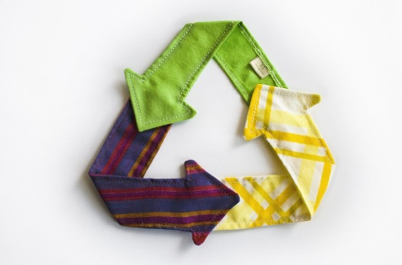
CDC is supporting the apparel sector to alleviate the impact on factory workers and people dependent on the apparel industry. CDC apparel program has two main objectives: aligning standards across the apparel industry and to concentrate on environmental impacts of apparel manufacturing. worker engagement and productivity training will improve managers’ understanding of employee perspectives and improve working conditions, which has proven to have positive effects on worker.

CDC brings together brands, public representatives, associations to learn more about and resolve sustainability issues in the industry, and to identify solutions and recommendations for developing a more sustainable apparel industry.

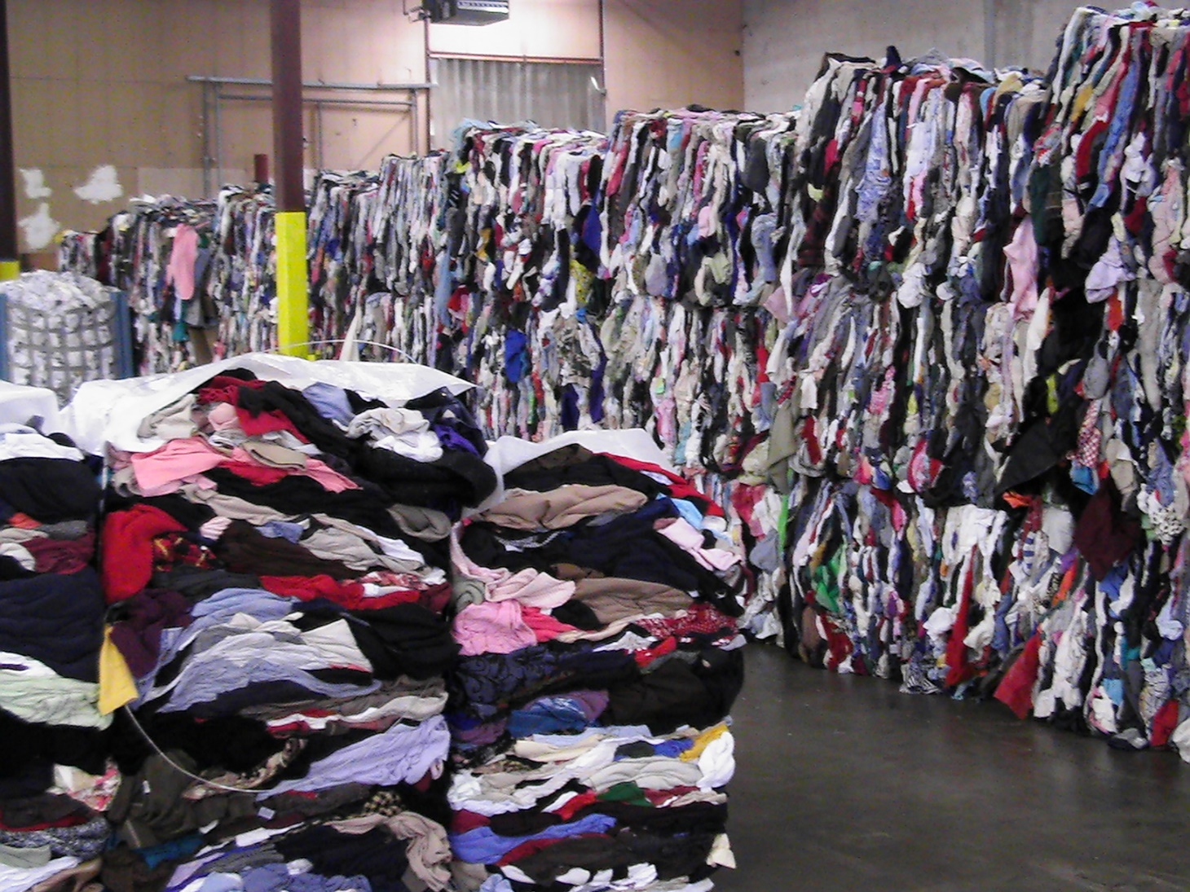
CDC helps identify opportunities for sustainable business models. We subsequently then a starting point for novice traders to develop and demonstrate best practices. These, in turn, help to illuminate their next around sustainable business practices.
EUROPEAN GREEN CAPITAL

